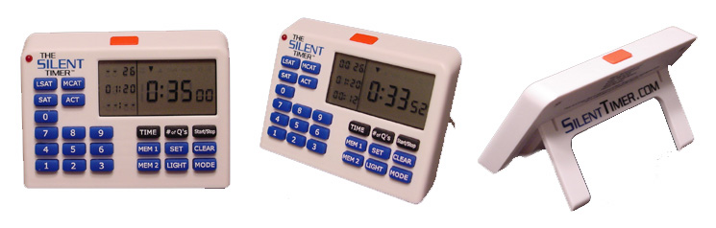

SILENT,
TEST-TAKING TIMER

THE SILENT TIMER™ will tell you everything you need to know about your test time:

- Count your time up or down
- Average your time per question
- Allot the time you can spend on each question
- Show you the number of questions answered
- Count number of questions remaining


Price: |   $24.95 (plus tax)
Order Deadline: | 10/24/2003 5:00pm
Office Code: | tpraus

To Order: Go to the web site and click on “Order Timer.” Then fill out the order form using your credit card. In the blank for “Office Code”, enter the office code above. After you submit your order, you will receive an e-mail confirmation. Your timer will be delivered to the office for pick up within 3-5 business days after the deadline above.

